Buddy Web Design
Kwikwap Training Exercise : Adding a website album
First log in to your website
Click on website content
Click on photo gallery
(If you do not see the link photo gallery it means that you may have to activate the photo gallery module first under additional modules)
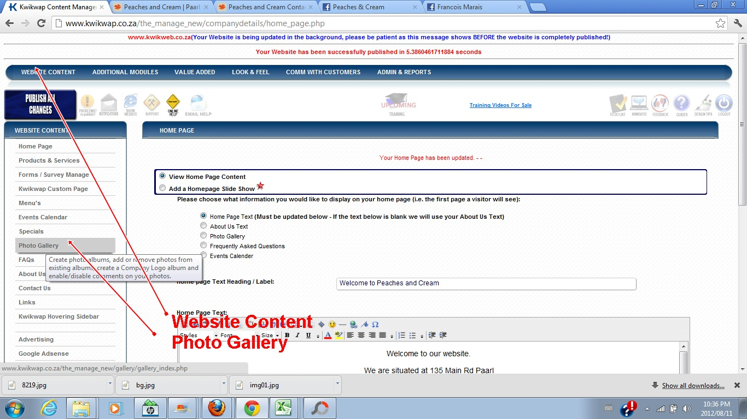
The following screen will appear:
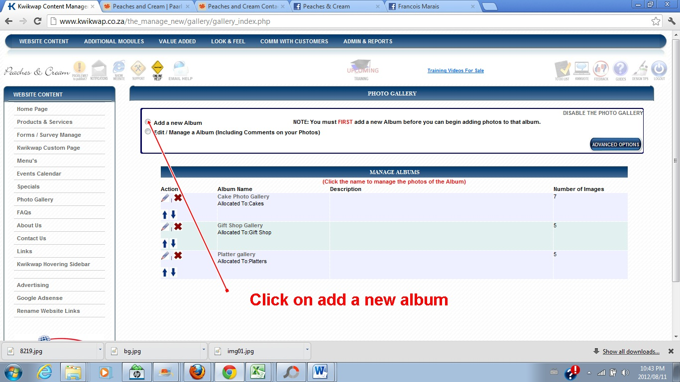
Click on add a new album
You will then have to give the album a name.
You have the option (not compulsory to give the album a description)
You have the choice to allocate the album to certain products and services pages.
Once you have chosen your album name and done the description you must click on add album.
You have now created a new photo album and you will be able to add photos to the album.
You will have to click on the album name. (After clicking on website content and then photo gallery).
This will be covered in a following exercise.

